

**Learning Guide:**

**American Flag**





# **Overview:**



The American flag is a rectangular shape composed of 50 white stars (which represent the 50 states), and horizontal white and red stripes (which represent the original 13 colonies in the United States). The 3D printed model replicates the American flag and captures each specific detail that makes up the flag. An actual American flag is 3 feet by 5 feet (91 cm by 152 cm) on average, which is almost the size of the roof of a car.

This model was designed by Mrugank for See3D.

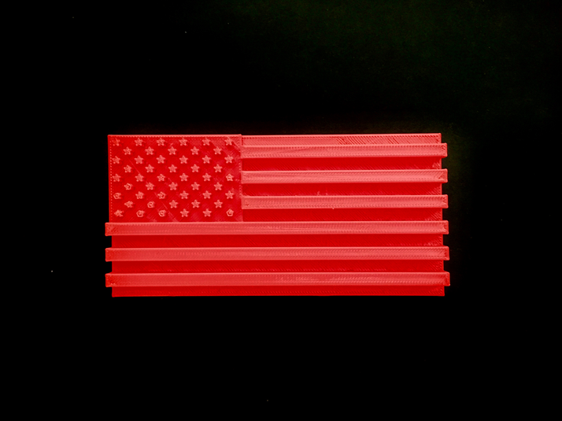

3D print of the American flag.

# **Walkthrough:**



1. Feel for the large group of raised stars in the top left-hand corner of the flag. Each star has 5 points and there are 9 rows of stars. In total, there are 50 stars that make up about 1/4 of the flag’s total area. The stars represent each of the 50 states in the United States of America. In the real flag, the stars are white.

2. After you have located the raised stars, feel for the surface that the stars are located on top of. Below the stars is a rectangle that is raised which is located in the top left area of the model. On the real flag, this rectangle is blue.

3. To the right of and below the blue and raised rectangle you just felt, there are horizontal stripes that make up the remainder of the flag. Start in the top right corner of the model and feel for a raised rectangle. The rectangle that is raised is skinny and represents a horizontal stripe on the flag. Move your finger down the model and you will feel more of these raised stripes. After you have felt the first 3 raised stripes, you will notice the stripes are longer and span across the entire flag. In the real flag, the raised stripes are white.

4. In between each of the raised stripes you just felt are the horizontal red stripes in the flag. The red and white stripes alternate, as do the raised and lowered stripes on the model. Like the raised stripes, after you feel 4 of the lowered stripes, the lowered stripes double their length and span across the entire flag. In total, there are 13 stripes (6 white and 7 red) and they represent the 13 colonies originally in America.

# **Citations:**



“Flag Dimensions.” *US History*, Independence Hall Association, 2020, www.ushistory.org/betsy/flagetiq3.html.

“History of the American Flag.” *PBS*, Public Broadcasting Service, 2020, [www.pbs.org/a-capitol-fourth/history/old-glory/](http://www.pbs.org/a-capitol-fourth/history/old-glory/).